***DUPLICATE CHAR IN STRING:***

***-------------------------------------------------------------------------------------------***

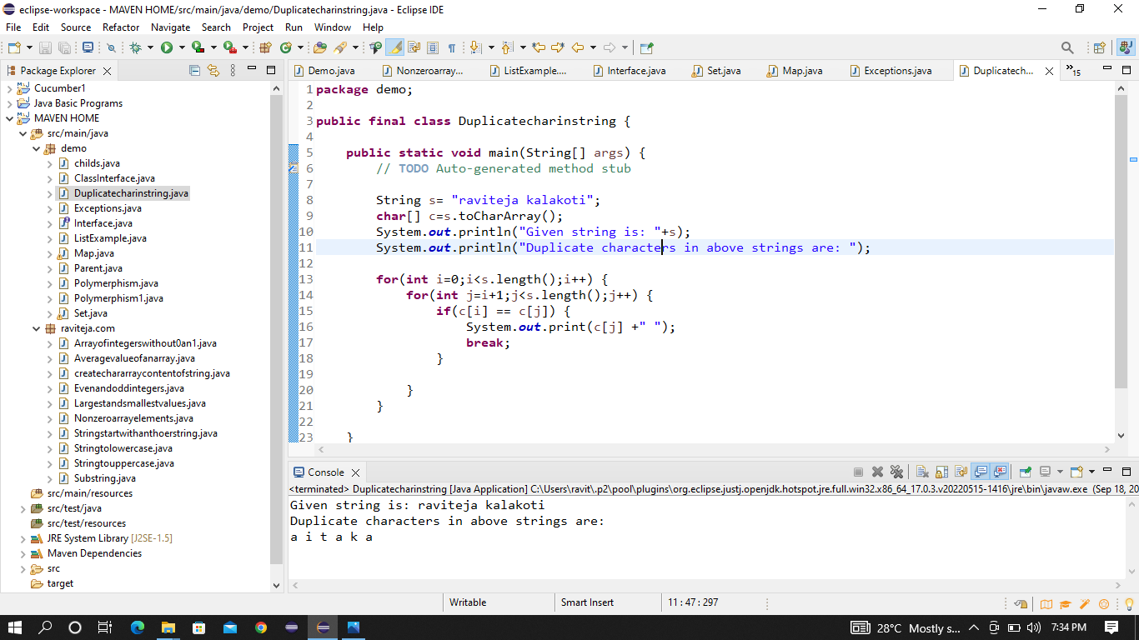

***EXCEPTIONS:***

***--------------------------------------------------------------------------------------------***

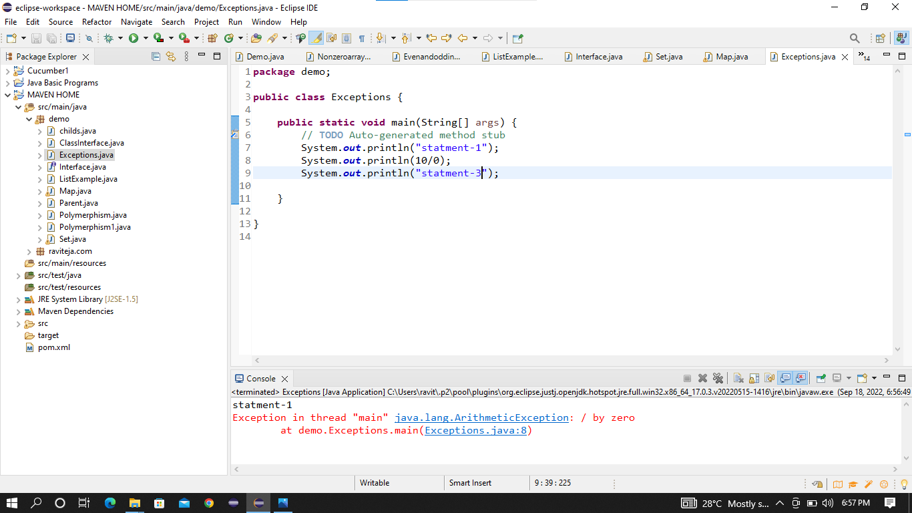

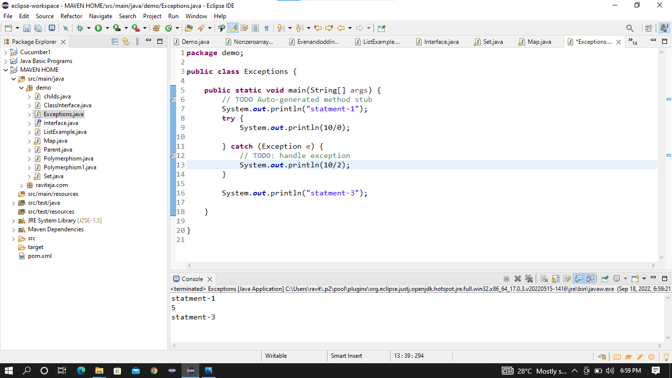

***SET:***

***------------------------------------------------------***

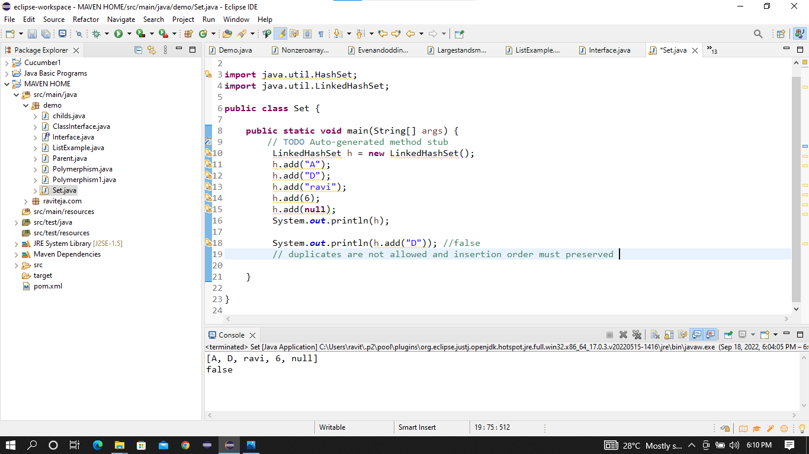

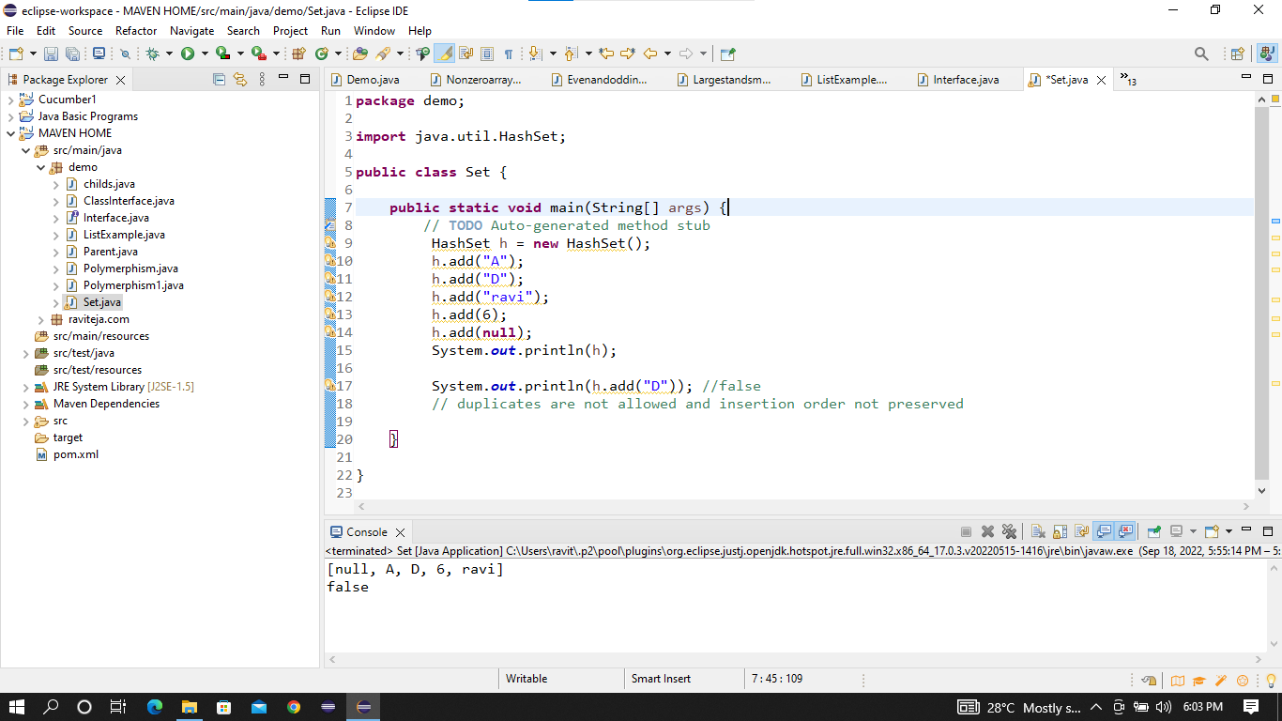

***MAP:***

***-----------------------------------------------------------------------------***

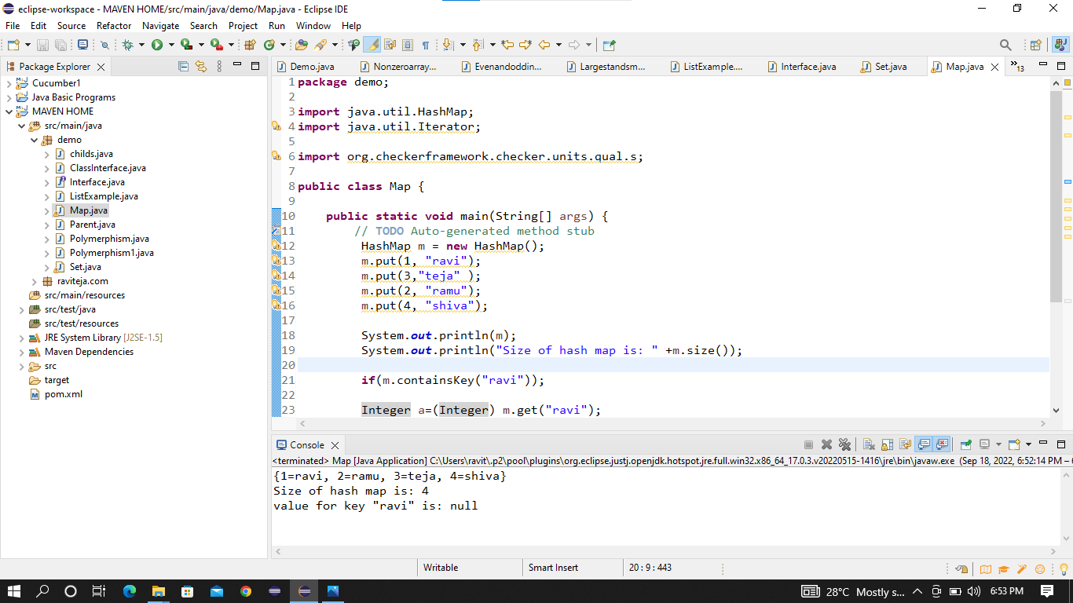

***LIST:***

***--------------------------------------------------------------------------------***

